H.T No
Regulations:
A22

Sreenidhi Institute of Science and Technology
(An Autonomous Institution)
Code No: 9HC14 Date:29-January-2025 (FN)

B.Tech II-Year I- Semester External Examination, January-2025 (Regular & Supplementary)
COMPLEX VARIABLES AND TRANSFORM TECHNIQUES (EEE and ECE)

Time: 3 Hours Max.Marks:60

Note: a) No additional answer sheets will be provided.
b) All sub-parts of a question must be answered at one place only, otherwise it will not be valued.
c) Missing data can be assumed suitably.
Bloom's Cognitive Levels of Learning (BCLL)

Remember | L1 | Apply | L3 | Evaluate | L5
Understand | L2 | Analyze | L4 | Create | L6

Part - A Max.Marks: 6x2=12

Answer all QUESTIONS, EACH QUESTION CARRIES 2 MARKS.

 |  | BCLL | CO(s) | Marks
1 | List the C-R equations in Cartesian coordinates. | L1 | CO1 | [2M]
2 | State Cauchy’s integral formula. | L1 | CO2 | [2M]
3 | Define conformal mapping. | L1 | CO3 | [2M]
4 | State first shifting theorem of Laplace transforms. | L1 | CO4 | [2M]
5 | Find the value of 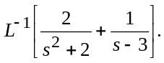 | L2 | CO5 | [2M]
6 | Write the formulas for Z[a^{n}] and Z[1]. | L1 | CO6 | [2M]

Part – B Max.Marks: 6x8=48
ANSWER ALL QUESTIONS. EACH QUESTION CARRIES 8 MARKS.

 |  | BCLL | CO(s) | Marks
7. | Prove that the complex function 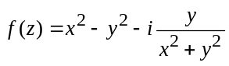 is not analytic but it is harmonic function. | L2 | CO1 | [8M]
 | OR
8 | Show that u(x,y) = e^{x}cosy is harmonic. Determine its harmonic conjugate and also find the analytic function. | L4 | CO1 | [8M]
9. | Evaluate 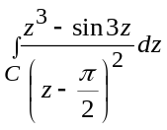, where 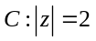using Cauchy’s integral formula. | L3 | CO2 | [8M]
 | OR
10 | Evaluate where ‘c’ is the circle using Residue theorem | L3 | CO2 | [8M]
11 | Find the bilinear transformation which maps the points z = 1, i, - 1 into the points w = 0, 1, ∞. | L3 | CO3 | [8M]
 | OR
12 | Show that the transformation 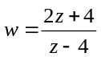changes the circle 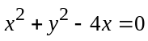into the straight line 4u + 3 = 0. | L4 | CO3 | [8M]
13 | Evaluate (i) 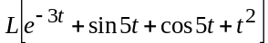 (ii) L[t.cos3t]. | L3 | CO4 | [8M]
 | OR
14 | Evaluate 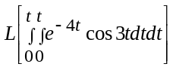. | L3 | CO4 | [8M]
15 | Using Convolution theorem, evaluate 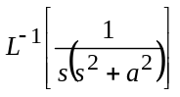. | L3 | CO5 | [8M]
 | OR
16 | Using Laplace transform, solve the differential equation 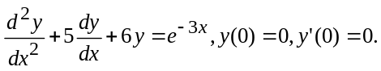 | L4 | CO5 | [8M]
17 | Make use of second shifting theorem of Z-transform, find the value of Z[u_{n+2}], if Z[u_{n}] = 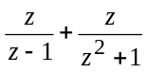. | L3 | CO6 | [8M]
 | OR
18 | Using Z-transform method to Solve y_{n+2} + 4y_{n+1}+3y_{n}=2^{n} with y₀ = 0, y₁ = 1. | L4 | CO6 | [8M]

-- 00 -- 00 –

